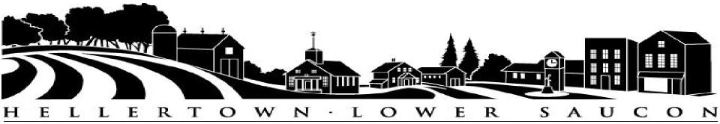
2019 COMMUNITY DAY
SPONSORSHIP OPPORTUNITIES
“PLATINUM” Sponsor - $1,000 – (only 1 available)
- Prominent recognition as the Platinum Sponsor on all printed marketing materials for the event.
- Opportunity to kick-off event with 3 minutes of stage time.
- Your Company’s own exhibit/vendor space “in the shade”.
- Banner placement opportunity at the band shell stage during Community Day events & continuous recognition throughout the day over the PA system.
- Frequent mentions on Hellertown-Lower Saucon social media pages.
“GOLD” Sponsor – $500
- Prominent recognition as a Gold Sponsor on all printed marketing materials for the event.
- Your Company’s own exhibit/vendor space.
- Banner placement opportunity in the Park during Community Day events.
- Recognition throughout the day over the PA system.
- Mentions on Hellertown-Lower Saucon social media pages.
“SILVER” Sponsor – $250
- Logo appears on all event posters distributed throughout the Borough of Hellertown and Lower Saucon.
- Your Company’s own exhibit/vendor space.
- Recognition throughout the day over the PA system.
“BRONZE” Sponsor – $150
- Logo appears on all event posters distributed throughout the Borough of Hellertown and Lower Saucon.
- Recognition throughout the day over the PA system.
“SUPPORTING” Sponsor – $75
If you are interested in participating in Community day as a Sponsor, return this form and your check in the appropriate amount made payable to “Borough of Hellertown - Community Day”, to: HLS Community Day c/o Borough of Hellertown, 685 Main Street, Hellertown, PA 18055.
Business/Organization Name ______________________________________________________________
Contact Person ________________________________ Title: ___________________________________
Phone: ________________________________________ E-Mail: _________________________________
Address: ___________________________________________________________________________
Sponsorship Amount: ___________________________________________________________________
** Deadline to participate is June 28, 2019 – Sponsorship’s received after this date are not guaranteed on marketing materials. Contact Amanda Buss at 484-515-0099 with any questions.

